**Exercise 3: Stored Procedures**

**Scenario 1:** The bank needs to process monthly interest for all savings accounts.

**Question:** Write a stored procedure **ProcessMonthlyInterest** that calculates and updates the balance of all savings accounts by applying an interest rate of 1% to the current balance.

**Query**

1. **Create the Table**

CREATE TABLE SAVINGS_ACCOUNTS (

ACCOUNT_ID NUMBER PRIMARY KEY,

ACCOUNT_HOLDER VARCHAR2(100),

BALANCE NUMBER(12,2)

);

**Output**

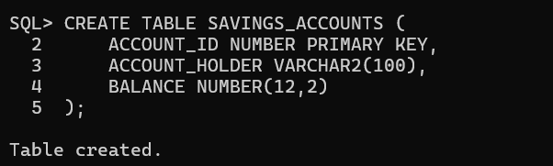

**Query**

1. **Insert Sample Data**

INSERT INTO SAVINGS_ACCOUNTS VALUES (1, 'Alice', 10000);

INSERT INTO SAVINGS_ACCOUNTS VALUES (2, 'Bob', 15000);

INSERT INTO SAVINGS_ACCOUNTS VALUES (3, 'Charlie', 8000);

COMMIT;

**Output**

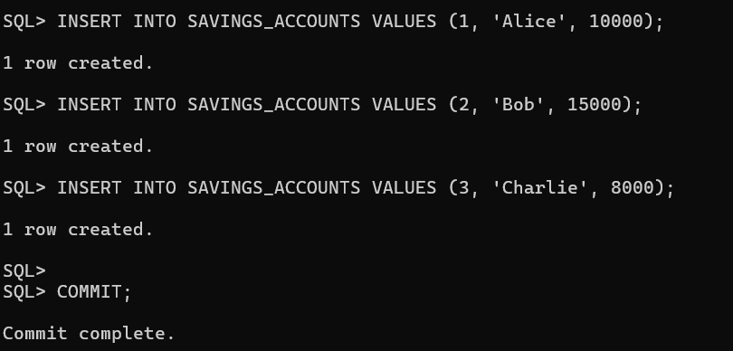

**Query**

1. **Create the Stored Procedure**

CREATE OR REPLACE PROCEDURE ProcessMonthlyInterest IS

BEGIN

UPDATE SAVINGS_ACCOUNTS

SET BALANCE = BALANCE + (BALANCE * 0.01);

COMMIT;

END;

/

**Output**

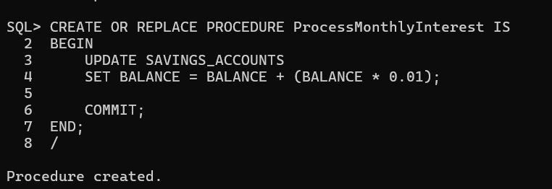

**Query**

1. Execute the Procedure

**Output**

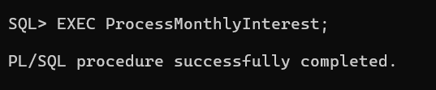

**Query**

1. **View Updated Balances**

SELECT * FROM SAVINGS_ACCOUNTS;

**Output**

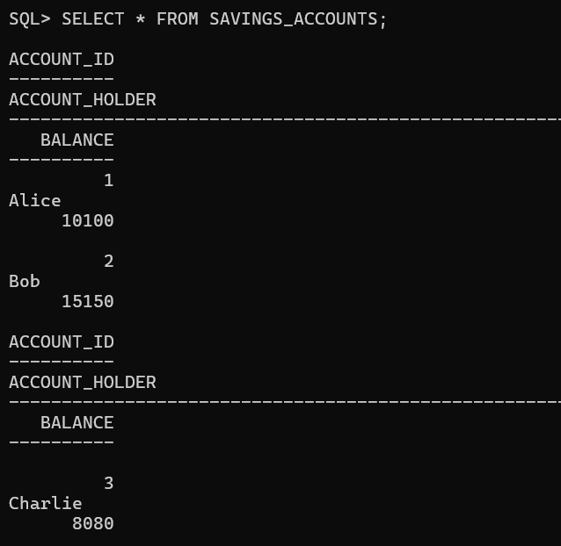

**Scenario 2:** The bank wants to implement a bonus scheme for employees based on their performance.

**Question:** Write a stored procedure **UpdateEmployeeBonus** that updates the salary of employees in a given department by adding a bonus percentage passed as a parameter.

**Query**

1. **Create EMPLOYEES Table**

CREATE TABLE EMPLOYEES (

EMP_ID NUMBER PRIMARY KEY,

EMP_NAME VARCHAR2(100),

DEPARTMENT_ID NUMBER,

SALARY NUMBER(10,2)

);

**Output**

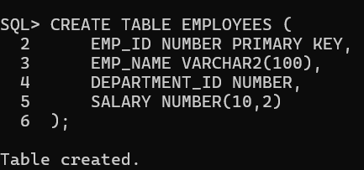

**Query**

1. **Insert Sample Data**

INSERT INTO EMPLOYEES VALUES (1, 'Alice', 101, 50000);

INSERT INTO EMPLOYEES VALUES (2, 'Bob', 101, 60000);

INSERT INTO EMPLOYEES VALUES (3, 'Charlie', 102, 55000);

INSERT INTO EMPLOYEES VALUES (4, 'Diana', 103, 70000);

COMMIT;

**Output**

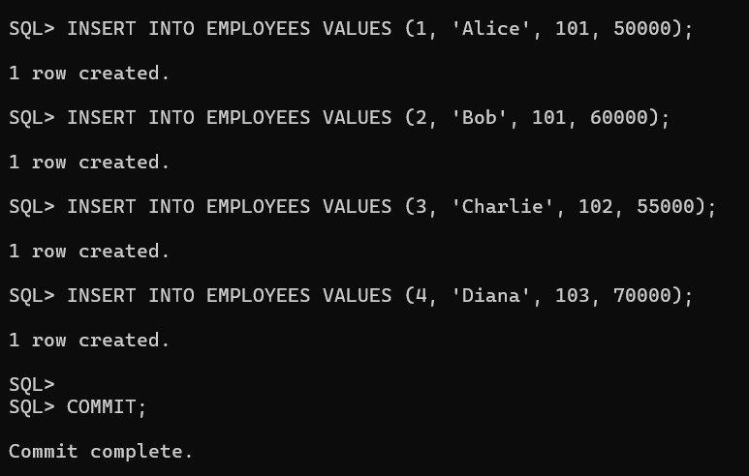

**Query**

1. **Create the Stored Procedure**

CREATE OR REPLACE PROCEDURE UpdateEmployeeBonus (

p_department_id IN NUMBER,

p_bonus_percent IN NUMBER

) IS

BEGIN

UPDATE EMPLOYEES

SET SALARY = SALARY + (SALARY * p_bonus_percent / 100)

WHERE DEPARTMENT_ID = p_department_id;

COMMIT;

END;

/

**Output**

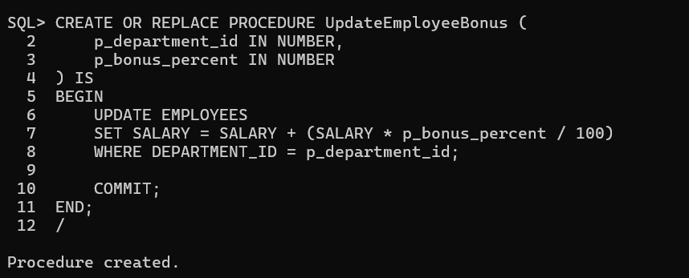

**Query**

1. **Execute the Procedure (Example: 10% bonus to dept 101)**

EXEC UpdateEmployeeBonus(101, 10);

**Output**

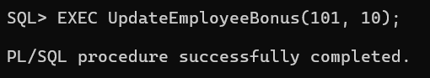

**Query**

1. **View Updated Salaries**

SELECT * FROM EMPLOYEES;

**Output**

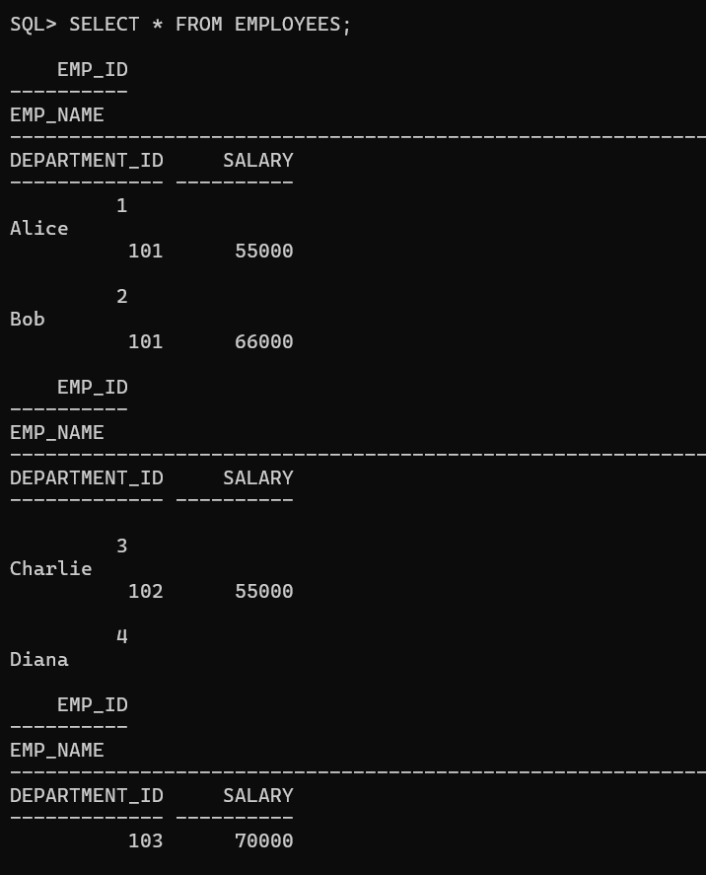

**Scenario 3:** Customers should be able to transfer funds between their accounts.

**Question:** Write a stored procedure **TransferFunds** that transfers a specified amount from one account to another, checking that the source account has sufficient balance before making the transfer.

**Query**

1. **Create ACCOUNTS Table**

CREATE TABLE ACCOUNTS (

ACCOUNT_ID NUMBER PRIMARY KEY,

CUSTOMER_NAME VARCHAR2(100),

BALANCE NUMBER(12,2)

);

**Output**

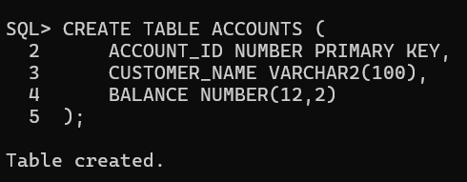

**Query**

1. **Insert Sample Data**

INSERT INTO ACCOUNTS VALUES (1, 'Alice', 10000);

INSERT INTO ACCOUNTS VALUES (2, 'Bob', 5000);

COMMIT;

**Output**

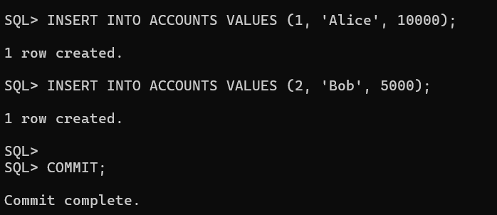

**Query**

1. **Create the Stored Procedure**

CREATE OR REPLACE PROCEDURE TransferFunds (

p_from_account_id IN NUMBER,

p_to_account_id IN NUMBER,

p_amount IN NUMBER

) IS

v_from_balance NUMBER;

BEGIN

SELECT BALANCE INTO v_from_balance

FROM ACCOUNTS

WHERE ACCOUNT_ID = p_from_account_id

FOR UPDATE;

IF v_from_balance < p_amount THEN

RAISE_APPLICATION_ERROR(-20001, 'Insufficient funds in source account.');

END IF;

UPDATE ACCOUNTS

SET BALANCE = BALANCE - p_amount

WHERE ACCOUNT_ID = p_from_account_id;

UPDATE ACCOUNTS

SET BALANCE = BALANCE + p_amount

WHERE ACCOUNT_ID = p_to_account_id;

COMMIT;

END;

/

**Output**

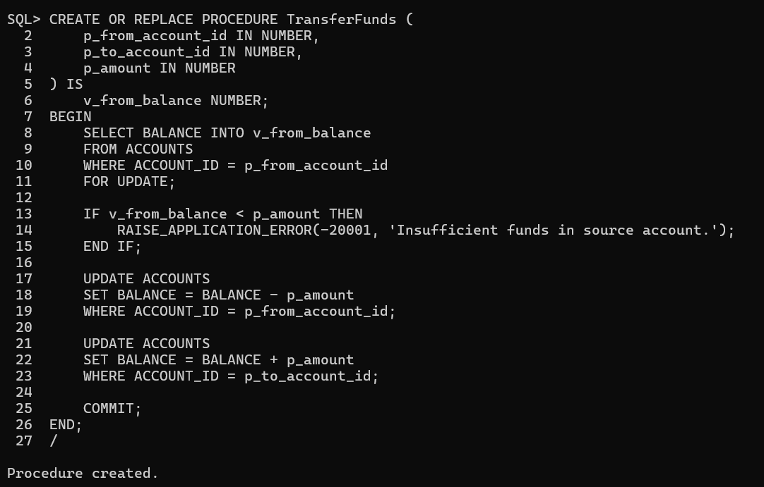

**Query**

1. **Execute the Procedure (e.g., Transfer 2000 from Alice to Bob)**

EXEC TransferFunds(1, 2, 2000);

**Output**

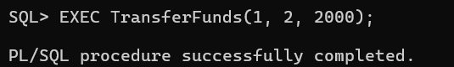

**Query**

1. **View Updated Balances**

SELECT * FROM ACCOUNTS;

**Output**

